Lab6

57117140 庞乃瑜

A:10.0.2.8

B:10.0.2.9

Task1:

• Prevent A from doing telnet to Machine B.

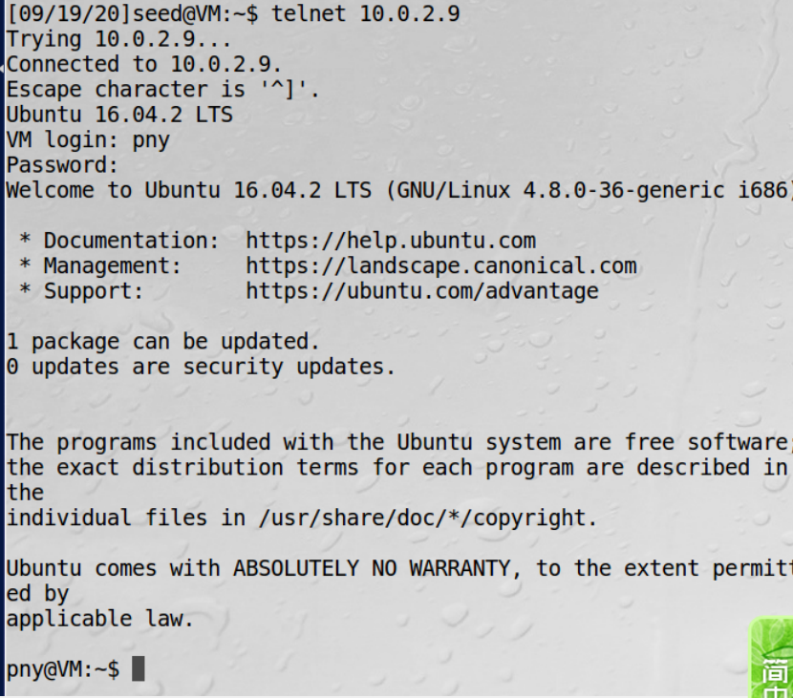

启用之前可以连接上

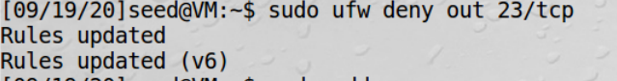



启用之后A无法telnet B

• Prevent B from doing telnet to Machine A.

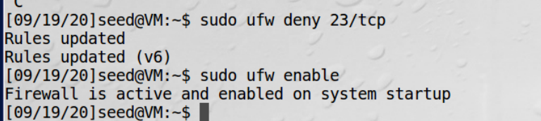



• Prevent A from visiting an external web site. You can choose any web site that you like to block, but keep in mind, some web servers have multiple IP addresses.

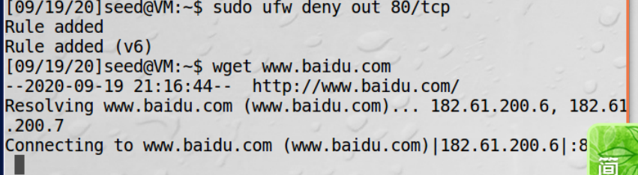

Task2:

Task3:

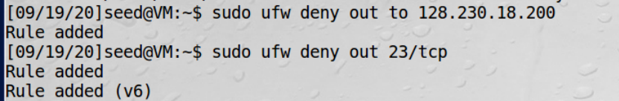

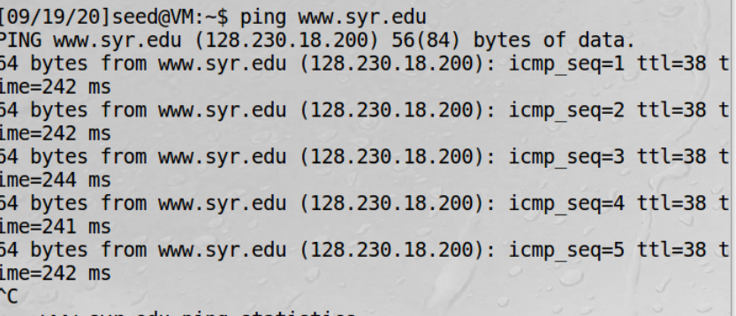

开启前能ping 通

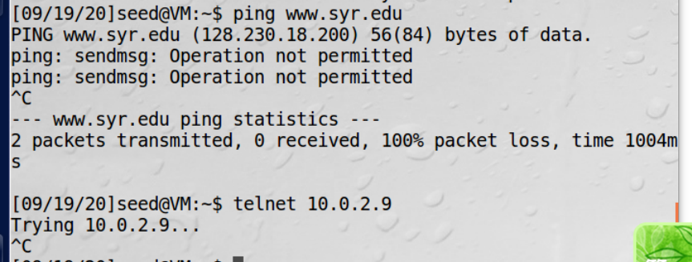

开启后不能ping通，telent 服务不能用

Task3a:

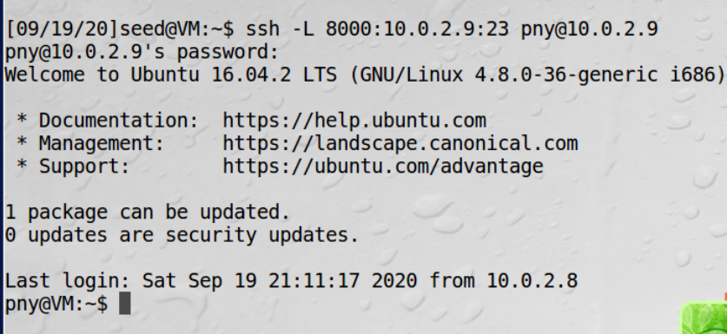

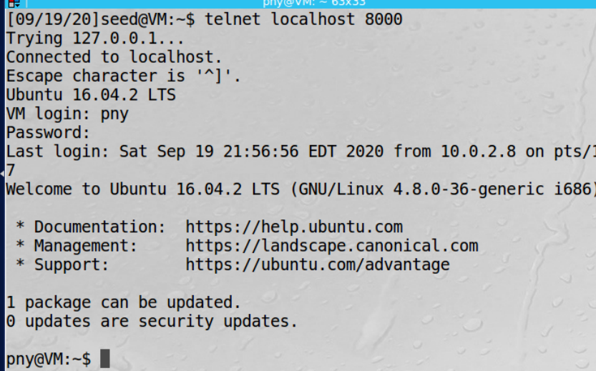

Task3b:

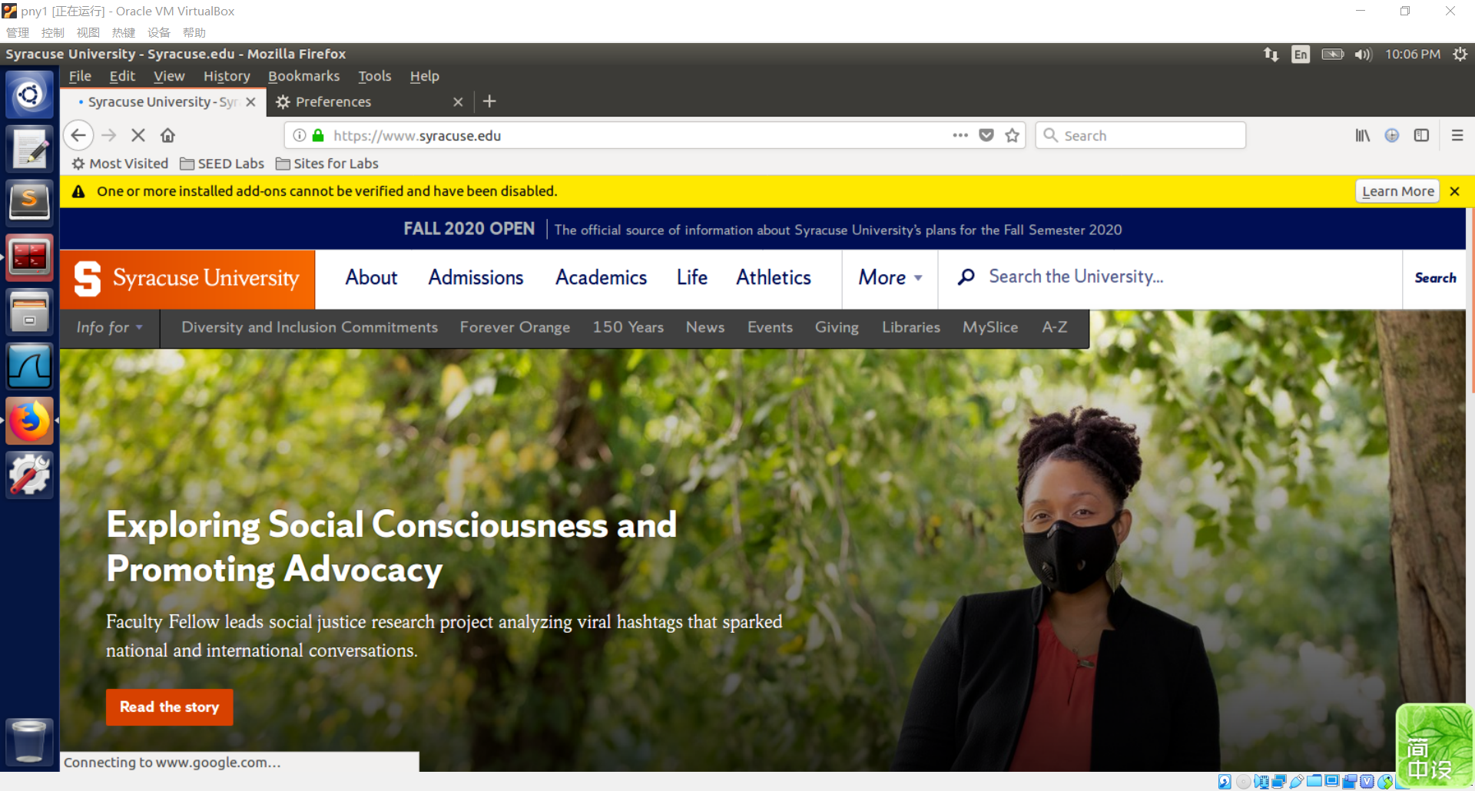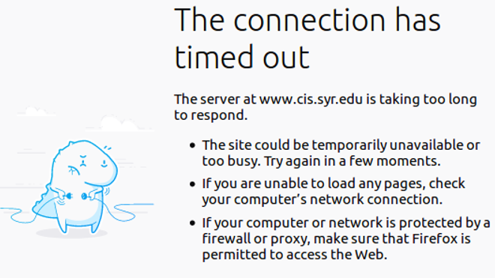

关闭后无法访问

重新建立通道后又能访问

通过wireshark抓包发现，A先将相关访问内容发送给B，B进行访问后再讲结果发送给A，所以关闭通道后A无法访问

Task4:

首先设置A的防火墙

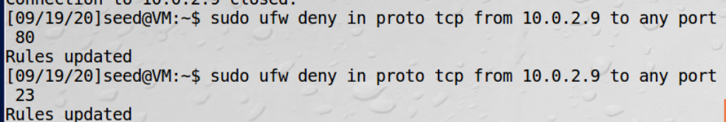

然后设置C，并设置逆向ssh通道

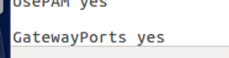

然后B过访问C，成功访问A

